PROJECT REPORT

Online Shoppers Purchasing Intention Prediction Using Machine Learning

A Machine Learning Approach for Predicting Whether an Online Visitor is Likely to Complete a Purchase

Prepared By :

Mate Atharva Vinayak

Branch: Information Technology

Institution: Matoshri Asarabai Institute of Technology and Research Centre, Eklahare, Nashik.

Academic Year: 2025–26

Certificate :

This is to certify that the project report entitled “Online Shoppers Purchasing Intention Prediction Using Machine Learning” is a bona fide work carried out by the student named on the title page under the prescribed academic requirements. The work presented in this report has not been submitted elsewhere for the award of any degree or diploma.

Date: Place:

Declaration :

I hereby declare that this project report is my original work. The ideas, analyses, and results presented here have been prepared for academic purposes, and all sources consulted have been acknowledged in the references.

Acknowledgement :

I would like to express my sincere gratitude to my institution, Matoshri Asarabai Institute of Technology and Research Centre, Eklahare, Nashik, and the Department of Information Technology for providing the academic environment required to complete this project. I also thank the faculty members and everyone who supported my learning during the development of this work.

I am grateful to the developers and communities behind Python, Jupyter Notebook, pandas, scikit-learn, joblib, GitHub, and Streamlit. Their tools and documentation made it possible to perform data analysis, build a machine learning workflow, save the trained model, and deploy an interactive web application.

Abstract :

Online businesses collect large amounts of information about visitor browsing behaviour. Predicting whether a visitor is likely to complete a purchase can help organizations understand customer behaviour and improve decision-making. This project presents a machine learning-based approach for predicting online shoppers’ purchasing intention from browsing-session information.
The project uses visitor and session-related attributes such as the number and duration of administrative, informational and product-related pages, bounce rate, exit rate, page value, special-day information, month, operating system, browser, region, traffic type, visitor type, and weekend status. The data is prepared for machine learning, a classification model is trained, and the trained model is saved for later use.
To make the project practical, the trained model is integrated into a Streamlit web application. Users can enter browsing details through a form and receive a prediction indicating whether the visitor is likely to purchase or not purchase. The application is deployed online through GitHub and Streamlit Community Cloud.
Keywords: Machine Learning, Classification, Online Shopping, Customer Behaviour, Purchase Intention, Streamlit, Web Application.

Table of Contents :

Chapter 1 – Introduction
Chapter 2 – Literature Review
Chapter 3 – Dataset and Data Preprocessing
Chapter 4 – Exploratory Data Analysis
Chapter 5 – Methodology
Chapter 6 – Machine Learning Model
Chapter 7 – Model Evaluation and Application Testing
Chapter 8 – Web Application Deployment
Chapter 9 – Conclusion and Future Scope
References
Appendix – Important Code and Application Details

List of Figures :

Figure 1 : Purchase Intension Distribution
Figure 2 : Purchase Rate By Month
Figure 3 : Confusion Matrix
Figure 4 : ROC Curve
Figure 5 : Feature Importance

Chapter 1 – Introduction

Background
The growth of e-commerce has made online visitor behaviour an important source of business information. During a browsing session, a visitor may view different types of pages, spend different amounts of time on them, arrive through different traffic sources, and visit during different periods. These signals can be analyzed to estimate whether the session is likely to end in a purchase.

Problem Statement
The problem addressed in this project is to predict purchasing intention for an online shopping session using available browsing and visitor attributes. The prediction is formulated as a binary classification problem: purchase intention and no purchase intention.

Objectives
    - Study online shopper browsing behaviour data.
    - Prepare the data for machine learning.
    - Identify useful numerical and categorical features.
    - Train a classification model for purchase intention prediction.
    - Save the trained model for reuse.
    - Build an interactive web application for predictions.
    - Deploy the application online for demonstration.

Scope
The project focuses on predicting the likely outcome of an online shopping session from the input variables supported by the application. It demonstrates an end-to-end workflow from data preparation and model use to a live web interface. The system is intended as an academic machine learning project and not as a replacement for complete commercial analytics systems.

Chapter 2 – Literature Review

Machine Learning in Customer Behaviour Analysis
Machine learning is widely applied to classification problems where historical examples are used to learn relationships between input features and an output class. In online shopping, behavioural attributes can provide useful signals about visitor engagement and purchase intention.

Classification Approach
A classification model receives a set of features and predicts a class label. In this project, the output is represented as a purchase-related decision. Classification is suitable because the desired result is a discrete outcome rather than a continuous numerical value.

Importance of Behavioural Features
Page visits, session durations, bounce rate, exit rate and page value can describe how a visitor interacts with an online store. Contextual variables such as month, visitor type, traffic type and weekend status can provide additional information about the session.

Practical Need
A prediction system can support understanding of customer behaviour, website analysis and targeted improvement. A web interface also makes the model easier to demonstrate because users can enter values and observe the output without working directly with Python code.

Chapter 3 – Dataset and Data Preprocessing

Dataset Overview
The project uses an online shoppers purchasing intention dataset containing browsing-session information. The application is designed around the following input fields: Administrative, Administrative_Duration, Informational, Informational_Duration, ProductRelated, ProductRelated_Duration, BounceRates, ExitRates, PageValues, SpecialDay, Month, OperatingSystems, Browser, Region, TrafficType, VisitorType and Weekend.

Feature Description
Administrative and Informational fields represent counts and durations of page categories. ProductRelated variables describe product-related browsing. BounceRates and ExitRates represent session interaction rates. PageValues represents page-related value information. Month, visitor type and weekend are categorical/contextual features, while operating system, browser, region and traffic type identify session categories.

Data Preparation
Before training a model, data is checked and prepared so that numerical and categorical values can be used consistently. Typical preparation includes checking missing values, reviewing data types, separating input features from the target variable, and transforming categorical variables when required by the chosen model.

Train and Test Data
The dataset is divided into separate subsets for model development and evaluation. The training portion is used to fit the machine learning model, while the testing portion is reserved for assessing how the trained model behaves on data not used for fitting.

Chapter 4 – Exploratory Data Analysis

Purpose of EDA
Exploratory Data Analysis is used to understand the structure of the dataset before modeling. It helps identify distributions, possible outliers, relationships among features and differences between classes.

Exploratory Data Analysis

Figure 1 : Purchase Intension Distribution

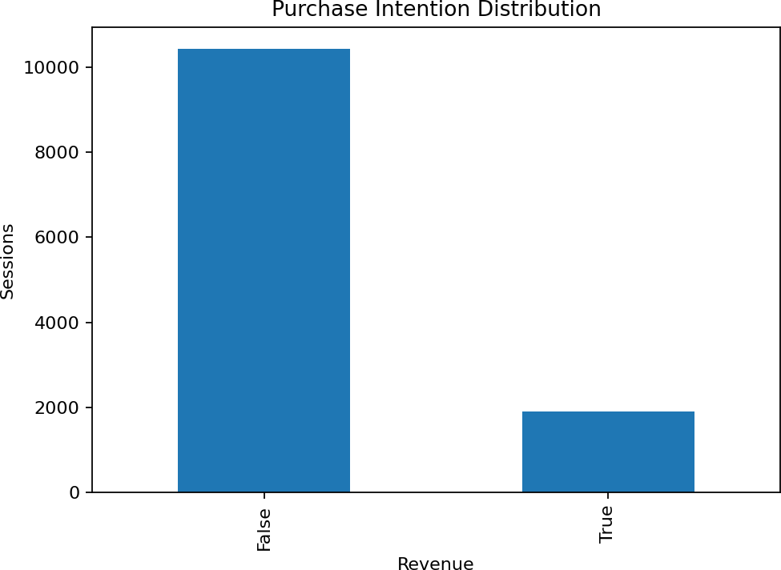

Distribution of purchase and no-purchase sessions.

Figure 2 : Purchase Rate By Month

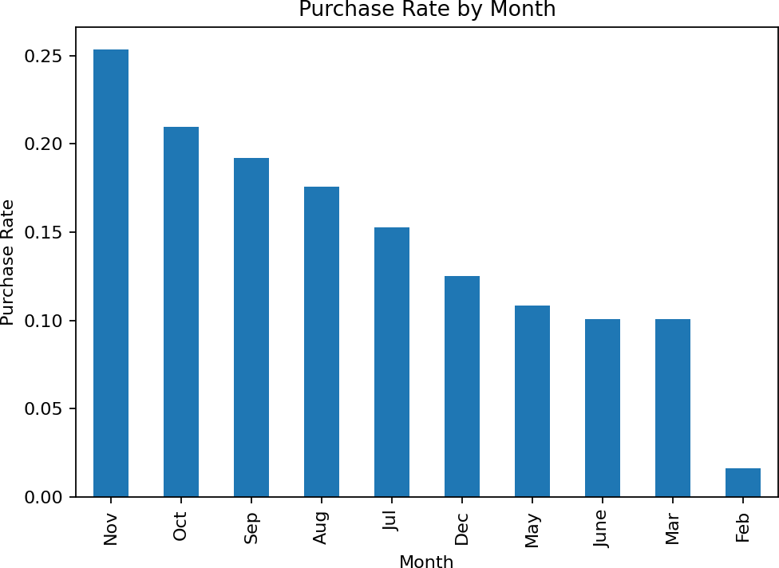

Average purchase rate across month categories.

4.3 Behavioural Analysis
For an online shopping dataset, useful observations can include how many pages are visited, how long visitors spend browsing, and whether high bounce or exit rates are associated with lower engagement. Page value and product-related activity can also be explored as indicators of shopping intent.

Categorical Analysis
Visitor type, month, traffic type and weekend status can be compared across sessions. These variables provide context that may help the model learn differences in visitor behaviour.

Importance of Visualization
Tables and graphs can make patterns easier to understand. Common visualizations include class-distribution charts, histograms for numerical variables, box plots, correlation views and category-wisecomparison

Chapter 5 – Methodology

Workflow
The project follows an end-to-end workflow: dataset loading  inspection  preprocessing  feature preparation  model training  model saving  web application integration  online deployment.

Model Input
The web application collects the same type of information expected by the trained model. The entered values are placed into a pandas DataFrame with named columns so that the prediction call can use a structured input.

Model Persistence
After training, the machine learning model is stored as a serialized file using joblib. A compressed model file was also created for easier repository upload and deployment. The deployed application loads the compressed model when it starts.

Prediction Logic
When the user clicks the prediction button, the application prepares the entered values, calls the model’s predict method and displays a result. The interface communicates one of two outcomes: the customer is likely to purchase or is not likely to purchase.

Chapter 6 – Machine Learning Model

Classification Model
The trained model used by the project is a classification model saved as a joblib file and integrated with the Streamlit application. The report focuses on the complete working pipeline rather than claiming performance values not independently reproduced in this report.

Model Loading
The Streamlit application uses a cached loading function to load the serialized model efficiently. This avoids unnecessary repeated loading during user interaction and supports a smoother application experience.

Application Inputs
The interface divides inputs into two columns for easier use. Numerical fields are collected with number-input controls, while categorical fields such as Month and Visitor Type are collected with selection controls.

Output
After prediction, the application displays a clear success-style message for a likely purchase and a warning-style message for a likely non-purchase.

Chapter 7 – Model Evaluation and Application Testing

Evaluation Principles
A classification project should be evaluated using appropriate measures such as accuracy, precision, recall, F1-score and a confusion matrix when these are generated during experimentation. Accuracy alone may not describe every aspect of model performance, especially when class frequencies differ.

Testing the Web Application
The deployed application was tested by opening the Streamlit interface, entering valid browsing values, and pressing the prediction button. The application successfully loads the saved model and returns a prediction through the user interface.

7.3 Model Evaluation and Application Testing
Figure 3 : Confusion Matrix

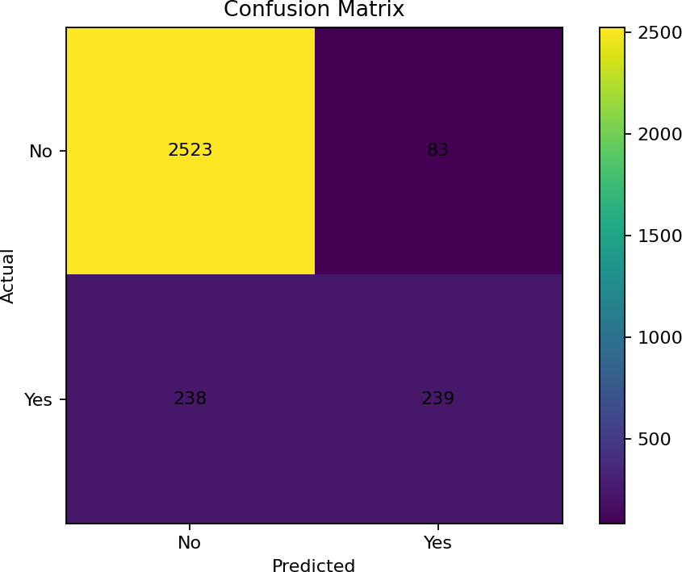
Correct and incorrect predictions on the held-out test set.

Figure 4 : ROC Curve

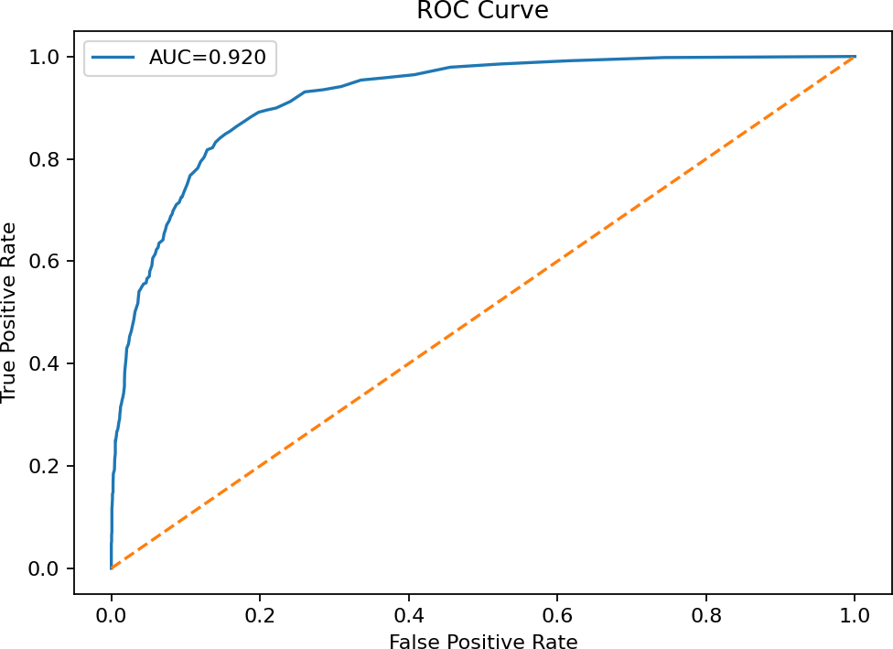
Classifier performance across decision thresholds.

Figure 5. Feature Importance

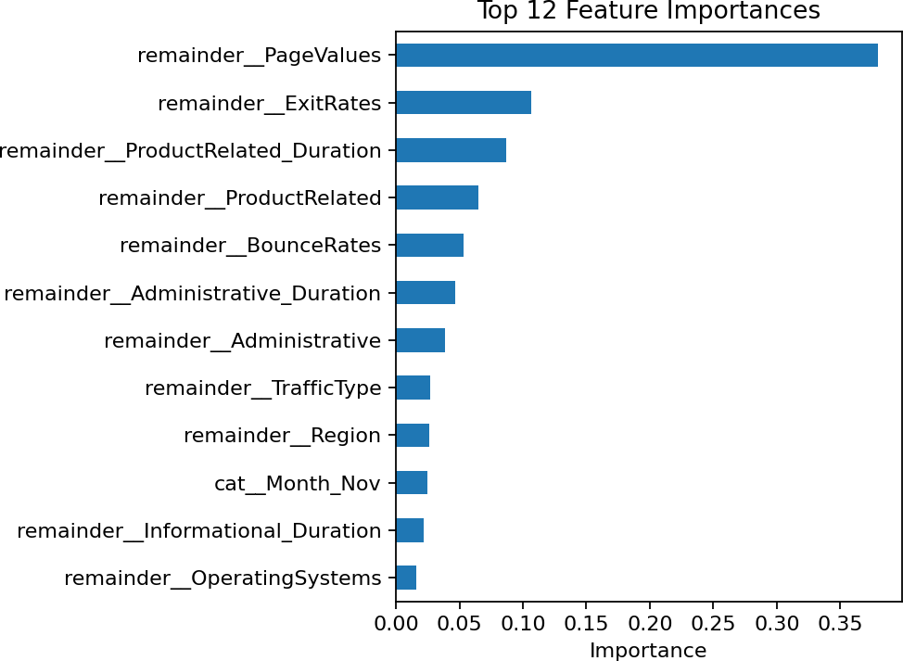

Top transformed input features ranked by model importance.

Deployment Validation
The project repository contains the application source file, compressed trained model and dependency file. The dependency list allows the cloud deployment environment to install the required Python packages before running the application.

Result Summary
The final deliverable is a functioning machine learning demonstration with a live interface. Because the exact evaluation outputs from the notebook are not reproduced in the material used for this report, no unverified numerical accuracy claim is included here.

Model Evaluation Summary :

Evaluation : stratified 75/25 split, Random Forest classifier with 120 estimators.

Metric | Value
Accuracy | 0.8959
Precision | 0.7422
Recall | 0.5010
F1-score | 0.5982
ROC-AUC | 0.9200

These metrics apply to the evaluation run generated for this updated report.

Chapter 8 – Web Application Deployment

GitHub Repository
The application files were organized in a GitHub repository. The main files include app.py, the compressed model file and requirements.txt. GitHub provides a version-controlled location from which the deployment platform can access the project.

Requirements File
The project uses Python libraries including Streamlit, pandas, scikit-learn, joblib and NumPy. These dependencies are listed in requirements.txt so that the cloud environment can install them.

Streamlit Community Cloud
The repository was connected to Streamlit Community Cloud. The main branch and app.py were selected as the application entry point. The deployment platform built the environment and started the application.

Live Application
The deployed application is available at:

https://online-shoppers-prediction-fnurkwrbvhbb6vlrjecwbt.streamlit.app/

The live deployment allows the project to be demonstrated from a browser without requiring the viewer to install Python or Jupyter Notebook.

Chapter 9 – Conclusion and Future Scope

Conclusion
This project demonstrates how machine learning can be used to predict online shoppers’ purchasing intention from browsing-session information. The work covers data preparation, model use, model storage and integration with an interactive Streamlit application.

Advantages
    - Provides an easy demonstration of a machine learning classification workflow.
    - Uses browsing and contextual features as inputs.
    - Offers predictions through a simple web interface.
    - The trained model can be reused without retraining for every prediction.
    - Cloud deployment makes the project accessible through a web browser.

Limitations
The prediction quality depends on the quality and representativeness of the training data. Visitor behaviour can change over time, and a model may require retraining when data patterns change. The current application is designed primarily as an academic project demonstration.

Future Scope
Future work can compare multiple algorithms, add automated hyperparameter tuning, display prediction probabilities, include richer visual dashboards, add explainability methods, support database logging and retrain the model periodically with updated data.

References :

- Python Software Foundation. Python Documentation.
- pandas Documentation – Data analysis and manipulation library for Python.
- scikit-learn Documentation – Machine learning tools for Python.
- joblib Documentation – Model persistence and serialization.
- Streamlit Documentation – Building and deploying data applications.
- GitHub Documentation – Repository and source code management.
- Online Shoppers Purchasing Intention dataset and related academic/learning resources used during project development.

Appendix – Important Code and Application Details

Application Dependencies
streamlit pandas scikit-learn joblib numpy

Core Application Logic
The Streamlit application loads the compressed trained model, collects customer browsing details through input controls, constructs a pandas DataFrame using the expected feature names, and calls the model prediction function when the user presses the prediction button.

Model Loading Concept
The project uses joblib to load the saved model file named online_shopper_model_compressed.pkl. The model is cached in the application to avoid unnecessary repeated loading.

Deployment Files

File | Purpose
app.py | Main Streamlit application
online_shopper_model_compressed.pkl | Saved compressed machine learning model
requirements.txt | Python dependency list
README.md | Repository/project information

